Boat Racing Festival

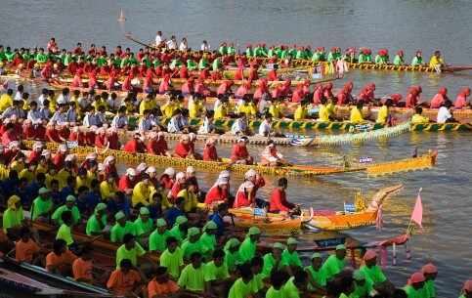

In Luang Prabang, Boat Racing Festival is held on Khao Padapdin (from the 17th to 18th August), including boat racing on the Nam Khan River and a trade fair in Luang Prabang City. In Vientiane, it is organized in the day after the End of Buddhist Lent, from the 2nd to 3rd October. In the evening, candlelight processions are held around the temples and hundreds of colorful floats decorated with flowers; incense and candle are set adrift down the Mekong River in thanksgiving to the river spirit. In the next day, an exciting boat racing competition is held on the Mekong.

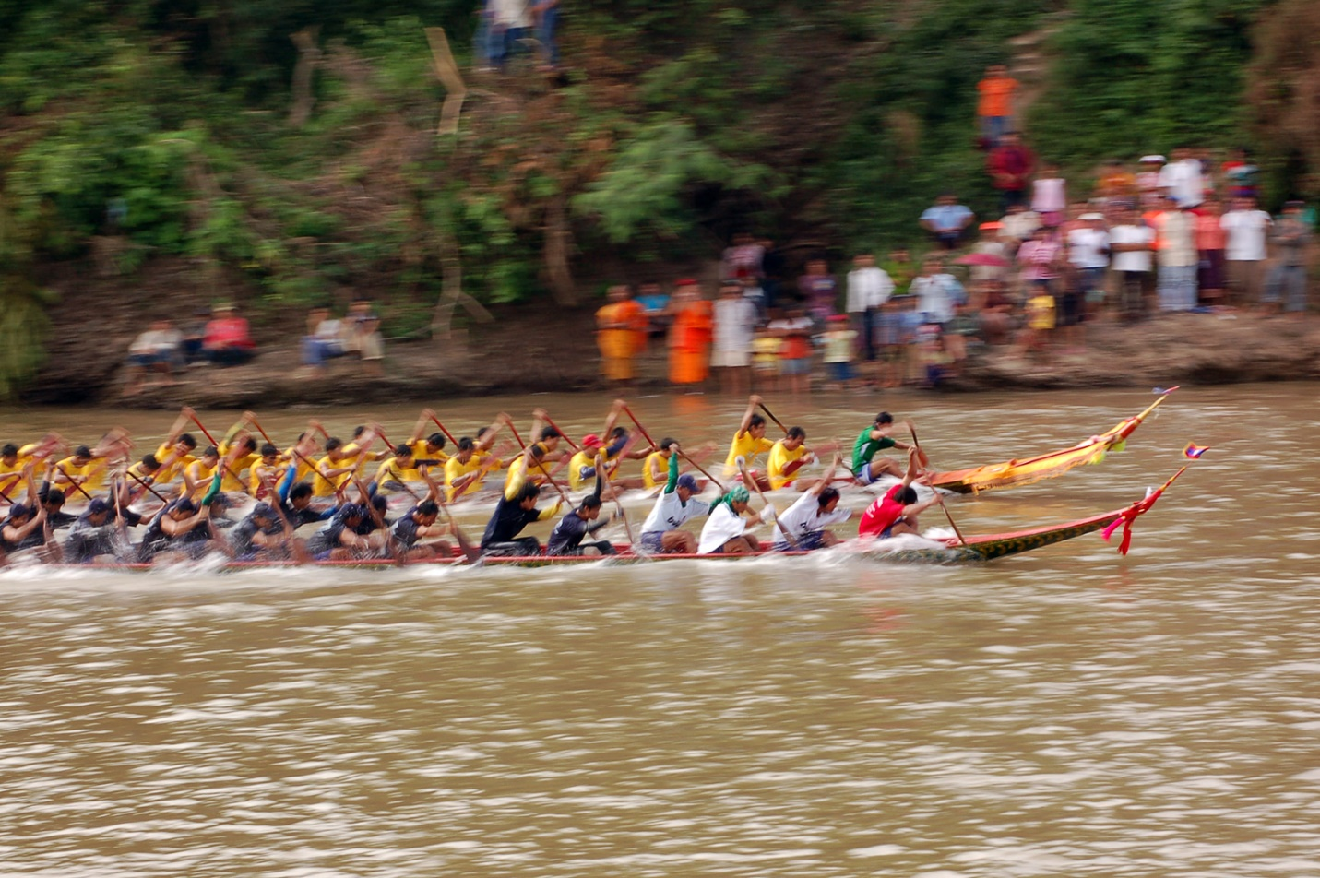

Dragon-style boats are carved from single trees holding up to 50 paddlers each. Women's teams compete in the morning, while men's crews race in the afternoon. Races work in heats with the finals at the end of the day where teams can win big prize money and the all-important trophy. The festival attracts flocks of spectators who line the river banks, singing and drumming. City centre streets are taken over with street food stalls and tombola games. The loud music and partying usually continues well into the night.